**“ONLINE BOOK STORE”**

A

Project Report

Submitted in partial fulfilment for the award of the degree of

**Bachelor of computer application**

By

**Vishwas Chourasiya**

**Enrolment No: Y21170865**



**Academic Session 2021-24**

**Department of Computer Science & Application**

**Dr Hari Singh Gour University Sagar M.P.**

**(A Central University)**

**2024**

**PLAGIARISM UNDERTAKING**

I Vishwas Chourasiya student of BCA VI Department of computer science and application, **Dr Harisingh Gaur University, Sagar (M.P.)**, solemnly declare that project work presented in the project report titled **“Online-Book-Store”** is solely my work with no significant contribution from any person. This project is carried out in the organization **Softseekers (SSI) Bhopal, Madhya Pradesh 462039** under the guidance of **Mr. Arvind Vishwakarma** small contribution/help wherever taken has been duly acknowledged and that complete report has been written by me.

I as an Author of the above titled project report declare that no portion of my report has been plagiarized and any material used as reference is properly referred/cities.

I undertake that if I am found guilty of formal plagiarism in the above titled report even award of degree, the University reserves the rights to withdraw/revoke my degree.

Student Name: Vishwas Chourasiya

Registration Number: Y21170865

Course: BCA VI SEM

Signature of Student: …………………

Date: 25 June 2024

Name of Project Supervisor: Mr. Arvind Vishwakarma (CTO of Softseekers)

**DR. HARISINGH GOUR UNIVERSITY**

**(A CENTERAL UNIVERSITY)**

**DEPARTMENT OF COMPUTER SCIENCE AND APPLICATIONS**



###### **CERTIFICATE**

This is to certify that **Vishwas Chourasiya** of BCA VI semester, **DEPARTMENT OF COMPUTER SCIENCE AND APPLICATIONS, DR. HARISINGH GOUR UNIVERSITY**, **Sagar (M.P)** Enrolment No. **Y21170865** have completed the major project titled Online-Book-Store. This project is partial fulfilment toward the award of degree of Bachelor of Computer Applications.

Forwarded by:

**Prof. Abhishek Bansal**

**(Cours Coordinator)**

**Prof. Abhishek Bansal**

**(Head of Department)**

**DECLARATION**

I, the undersigned Vishwas Chourasiya student of Bachelor in Computer Applications Semester-VI at **DEPARTMENT OF COMPUTER SCIENCE AND APPLICATIONS, DR. HARISINGH GOUR UNIVERSITY** hereby declare that the project work presented in this report is my own work and has been carried out under the guidance of , Mr. Arvind Vishwakarma at Softseekers (SSI) Bhopal, Madhya Pradesh 462039 for the period of 3 months from 28 February 2024 TO 28 April 2024.

This work has not been previously submitted to any other University/College for any examination.

Place: Sagar Vishwas Chourasiya

Date: 25 June 2024 Y21170865

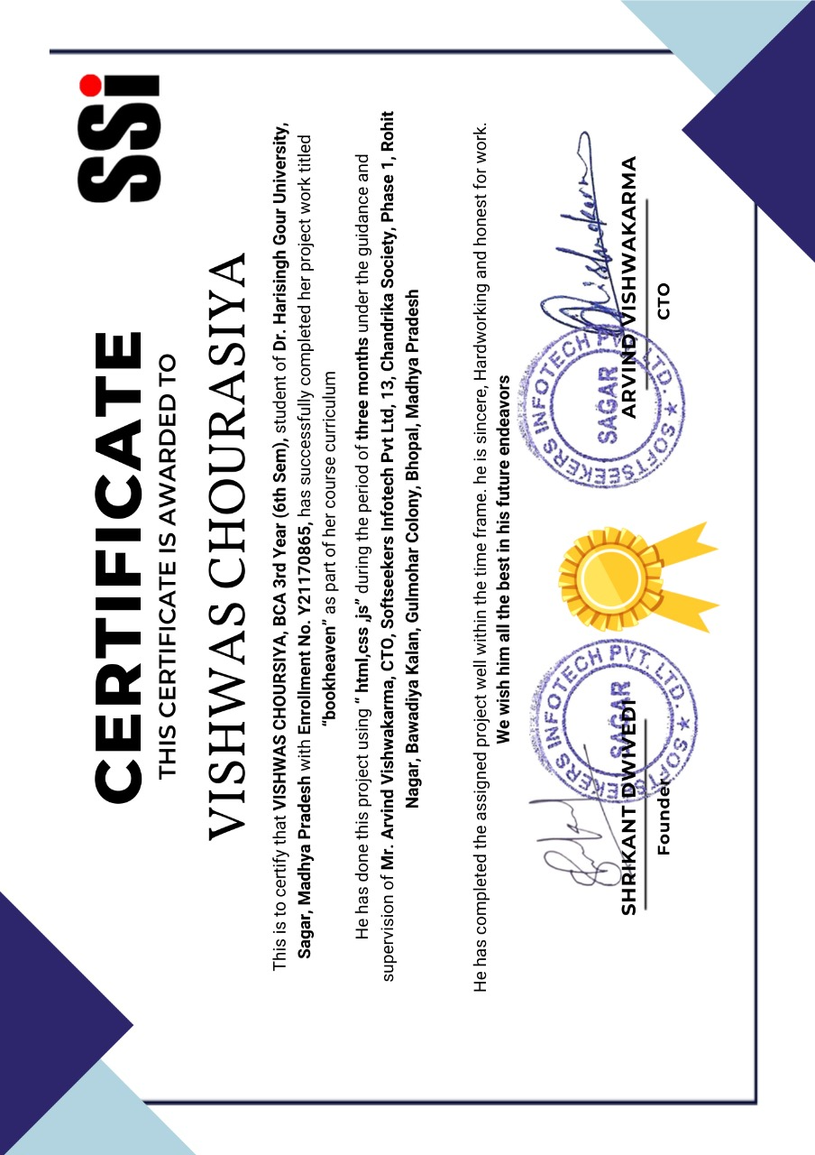

**TRAINING CERTIFICATE**

**Acknowledgment**

I would like to express my sincere gratitude to all those who have contributed to the successful completion of this web development project. This project marks a significant milestone in my academic journey, and it would not have been possible without the support and guidance of many individuals.

First and foremost, I would like to thank my project supervisor, Mr. Arvind Vishwakarma, for their invaluable guidance, feedback, and support throughout the course of this project. Their insights and expertise have been instrumental in shaping this project.

I am also grateful to, DR. HARISINGH GOUR UNIVERSITY, particularly the DEPARTMENT OF COMPUTER SCIENCE AND APPLICATIONS department, for providing the necessary resources and facilities to carry out this project. The knowledge and skills acquired during my studies have been fundamental in the development of this project.

I would also like to extend my gratitude to my family for their unwavering support and understanding throughout my academic journey. Their encouragement and belief in my abilities have been a constant source of motivation.

Finally, I would like to acknowledge the various online communities, forums, and open-source contributors whose resources and knowledge have greatly assisted me in overcoming numerous challenges during the development process.

Thank you all for your invaluable contributions.

Vishwas Chourasiya  
08-06-2024  
Dr Hari Singh Gour University Sagar MP

**Check This Project in Git hub Repository**

**[https://github.com/Localboy12/](https://github.com/Localboy12/Online-book-store-update.git)****[Online-book-store-update.git](https://github.com/Localboy12/Online-book-store-update.git)**

# Abstract

The online bookstore project aims to develop a comprehensive and user-friendly e-commerce platform that facilitates the seamless purchase of books for customers and efficient management of inventory and orders for administrators. The system encompasses functionalities such as user registration, book browsing, shopping cart management, secure payment processing, and order tracking. It also includes an admin dashboard for managing books, categories, and orders.

The primary objective of this project is to create an accessible and convenient online platform that enhances the traditional bookstore model by providing customers with the ability to shop for books from anywhere at any time. This project leverages modern web technologies and best practices in software development to ensure a robust, scalable, and maintainable system.

**Key Contributions:**

1. **User-Friendly Interface**: Developed an intuitive and responsive user interface using HTML, CSS, and JavaScript, ensuring a positive user experience on both desktop and mobile devices.
2. **Secure Authentication and Payment**: Implemented secure user authentication using PHP sessions and integrated Stripe for secure payment processing, ensuring the protection of user data and transactions.
3. **Efficient Book Management**: Designed and implemented a comprehensive book management module that allows administrators to add, edit, and delete book records, manage categories, and track inventory.
4. **Order Processing System**: Created a streamlined order processing workflow, including features such as shopping cart management, checkout process, and order confirmation.
5. **Database Design**: Designed a normalized database schema using MySQL, ensuring efficient data storage, retrieval, and integrity.
6. **Scalability and Performance**: Utilized caching mechanisms and optimized SQL queries to enhance the performance and scalability of the system, ensuring it can handle a large number of users and transactions.
7. **Testing and Validation**: Conducted thorough unit and integration testing to ensure the reliability and correctness of the system. Utilized tools such as PHPUnit and Selenium for automated testing.

This project demonstrates the application of software engineering principles and best practices in developing a functional and scalable e-commerce platform. The developed system not only meets the immediate needs of users and administrators but also lays a solid foundation for future enhancements and scalability. Through this project, significant contributions were made in terms of design, implementation, and testing, resulting in a robust and user-centric online bookstore.